**GeoChat**

# Create by Kyle Deak and John Delaney

Phase 3 Report

**August 6, 2017**

# Overview

Kyle finished work on the HTML and display PHP pages and John added SSL to the site to allow multiple browser access. The website is using a recycled DNS since it still has 3 months left on the subscription. <https://www.expweather.com/index.php> will give you a progress check on how far the website is along. According to timelines and milestones tracking we are still on track and maintain a 100% on-time rating with 100% code completion rate.

# Timelines and Milestones

Phase 1.

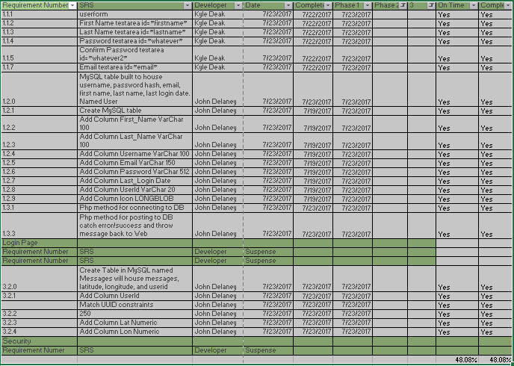

Phase 2.



Phase 3.

Mainly testing and ensuring error handling is implemented.

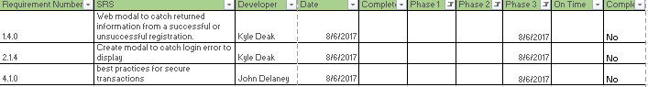



Testing revealed a few more things to fix, user registration does not provide a feedback page, login does not redirect you to the map.php page as coded and a failed picture upload gives a non-styled page. These three things will be fixed in Phase 4.

# Lessons Learned

1. **GitHub:** First time for John using Github so there was a learning curve on how to correctly push, commit, clone and other various commands. Learning merging and status’ of folders and repos.
2. **XAMPP Stack:** Kyle had a learning curve using the XAMPP install and getting it up and running. We both have a mirror of the server setup and can replicate the website. Getting the database configurations were a little tricky.
3. **Communication:** The development team moved their communication method over to Slack and integrated GitHub and Google Drive into our channels. The sharing of files is easier for proof of concepts and snippets of code for use between the developers.
4. **Mirroring:** We can also pull requests from GitHub to update the setup at each of our locations. John currently has the site live on the internet for display purposes. This will be the challenge to ensure our settings remain the same throughout out the project. GitHub has made this process very easy to get the site running on two servers and keep our versions the same.
5. **Challenge Lesson:** Talk about the details of design and pros and cons before development. PHP can do OOP and can be more complex to implement into web forms. Although the register method is complete, it will be rewritten for ease of debugging and phase development.
6. **SSL:** Some browsers will not use geolocation over unsecure protocols. Firefox, Chrome and mobile device are a few that did not render the leaflet map until SSL on the server was enabled.
7. **PHP to JSON to JavaScript:** Kyle learned to convert the query from PHP JSON format to a JavaScript variable for iteration in order to display all the messages within the database.

# Phase 3 Functionality:

**Testable Website Link:**  <https://www.expweather.com/index1.php> - Of note this is running on a laptop computer and is subject to being unplugged because family members do not understand running web servers from a laptop.

**Source Code Link:** <https://www.github.com/sd19surf/CMSC495> - Source code and version control is being hosted on GitHub.

**Screenshots:**

## On-Load:

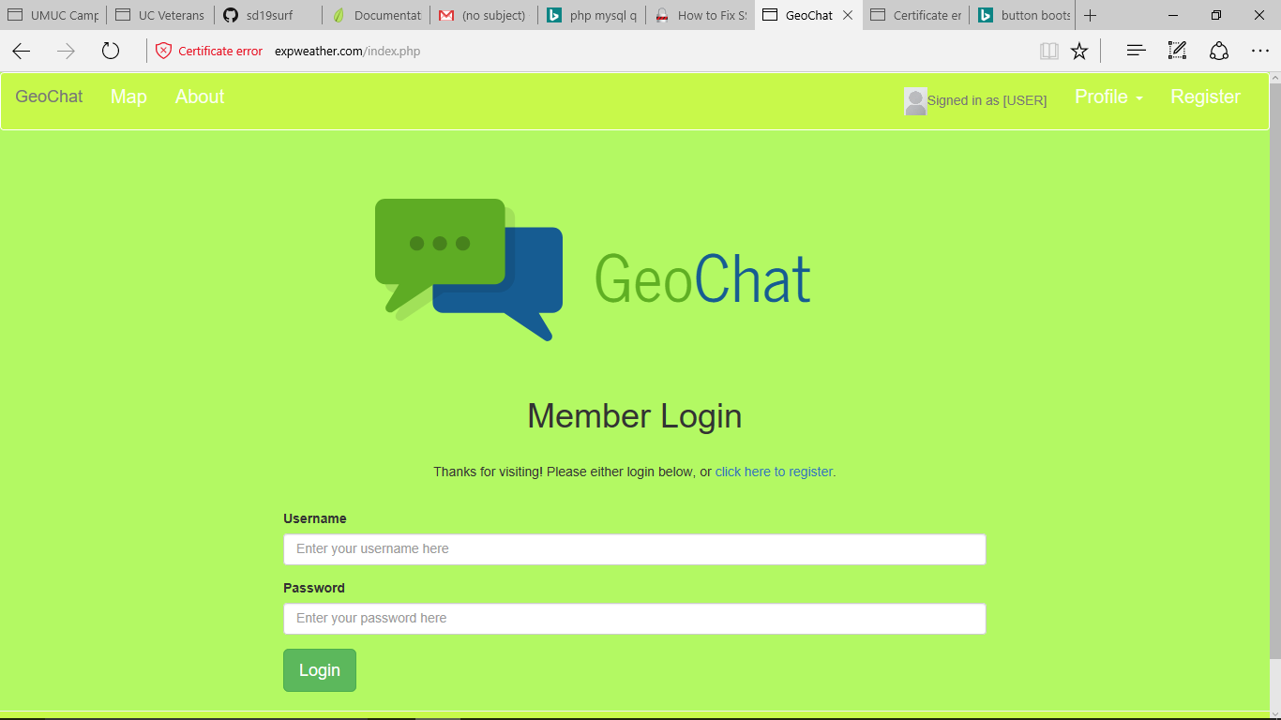

Webpage loads upon visiting the website. Content for Homepage and Map are placeholders until complete.

## User Registration

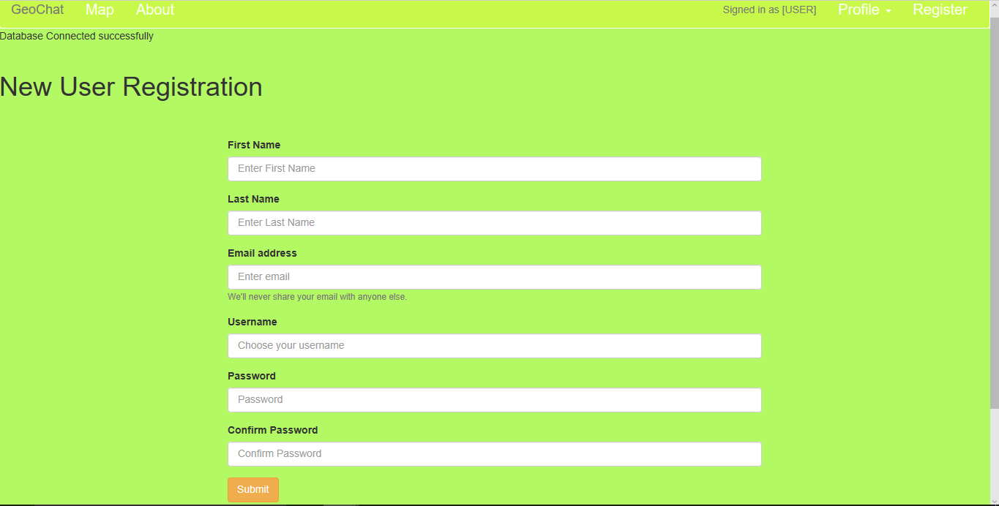Upon Submit the page references the text areas and returns values in the URL. The Database connection is successful and will be rewritten to accept values as an independent method instead of a class method.

## 3. Database Registration

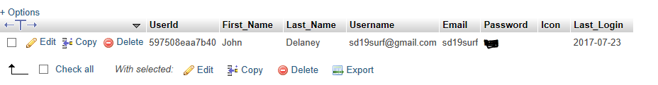

First registered user in the database, however password hash has been accomplished yet. Passwords are now confirmed and hashed.

## 4. Login Process

The login page has been completed and session variables are active allowing users to move about the website without having to log in again and again. Simple GUI and similar to other pages for a better UI.

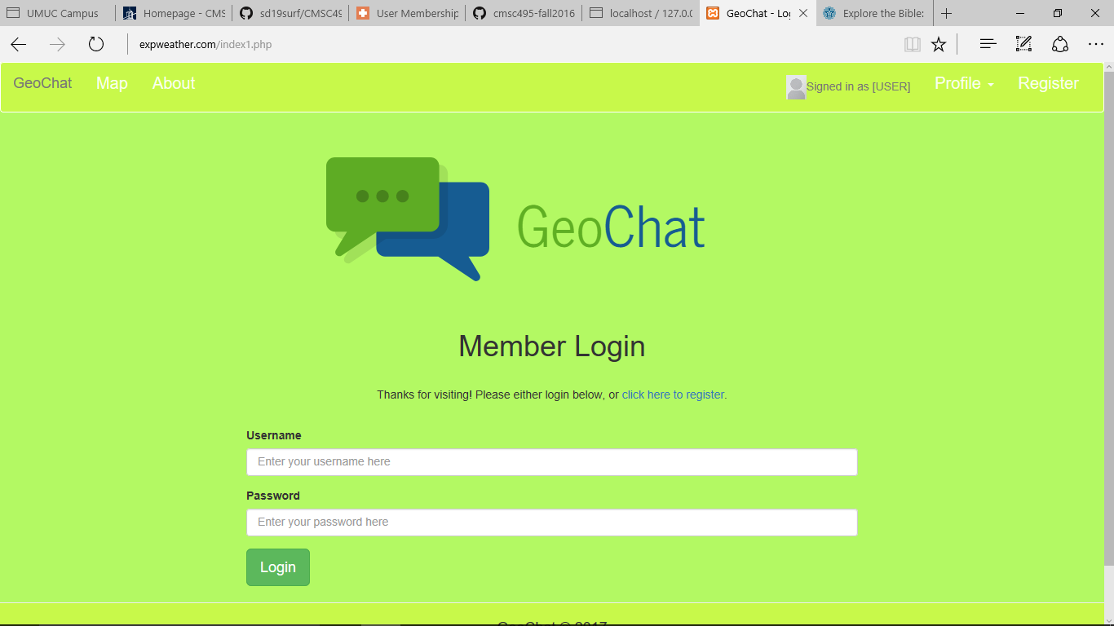

## 4. Upload Avatar

The process to upload a picture to use alongside the username has been completed and the link is located under the Profile and takes you to a landing page as seen below.

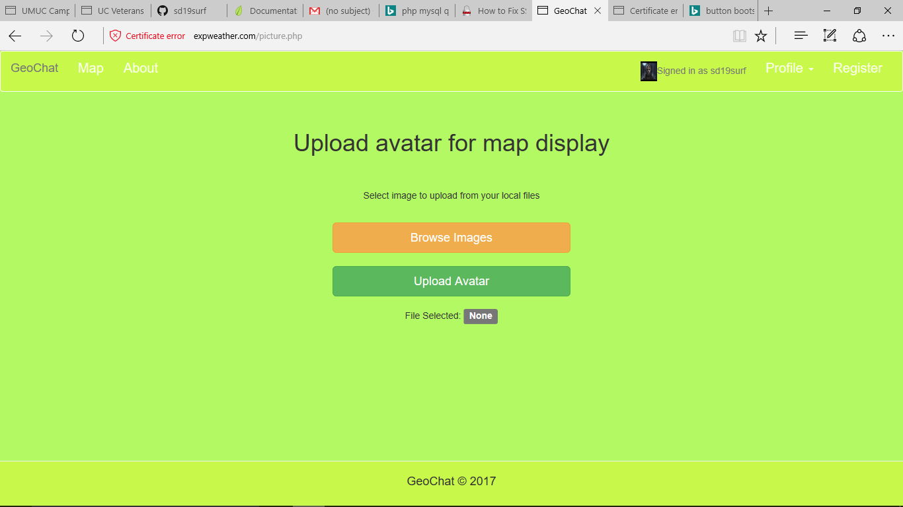

Clicking browse with open your computer’s folder and allow you to upload a png, jpg or gif image under the size of 50KB. If these conditions are not met then an error screen appears and the image is not loaded.

## 5. Map and Chat Screen

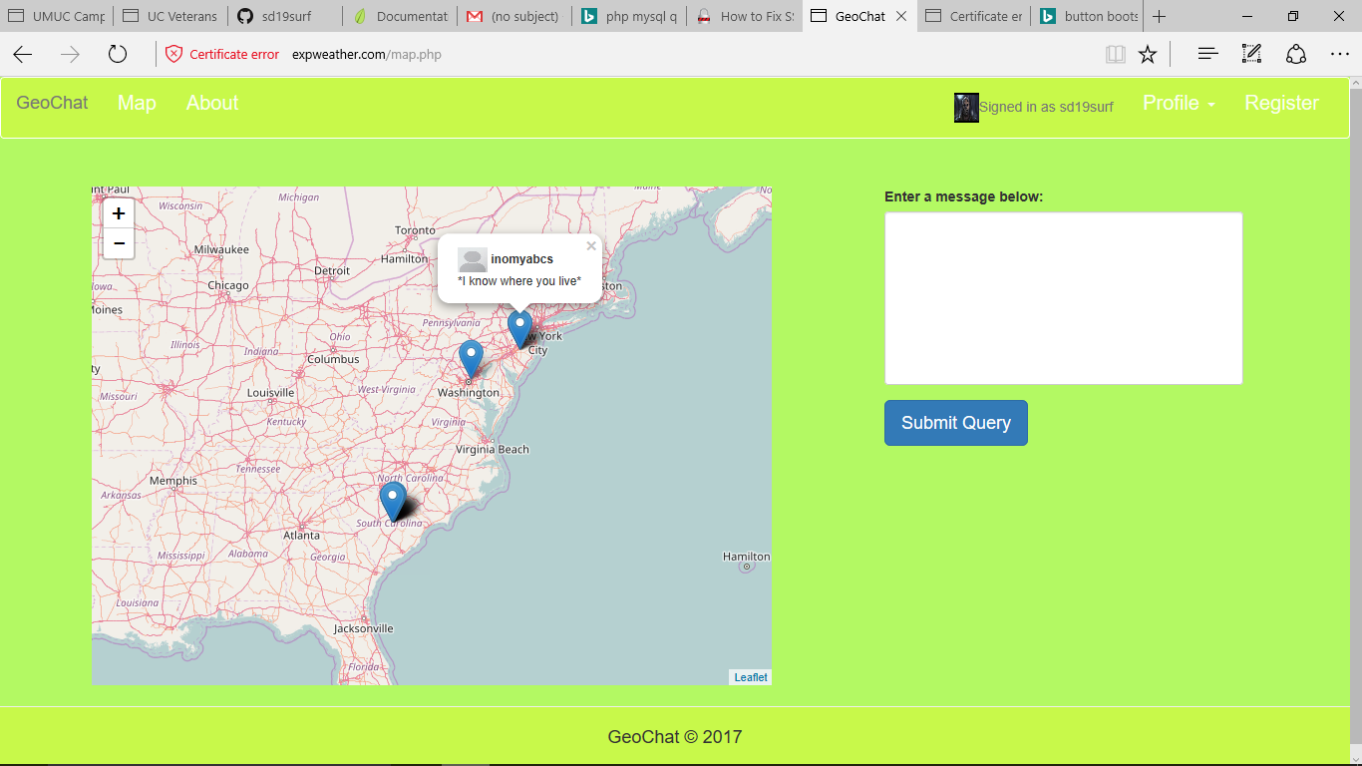

Map is now operational and messages display to the screen. A friend registered and typed a message from New Jersey to show location differences.

# Phase 2 Changes to design:

## 1. Database

There were a couple of changes to the database from the initial design. The column for timestamps was added to the messages table so the SQL query could filter on time and duration if needed in the future. Potential of having too many messages and no way to thin down the viewing to the user so that column was added. A change to the user table on the Icon column was from BLOB to MEDIUMTEXT. This change was to eliminate storing pictures in the database instead storing the location of the picture. This sped up the calls to the database.

## 2. PHP Methods

The decision to keep the methods in single files makes it easier to make a modular design and work on pieces of the website at different times.

## 3. HTML Design

CSS enhancements to the login page and consequently other pages by inheritance has made the web application smoother and more appealing.

# Phase 3 Changes to design:

## 1. Database

No additional changes

## 2. PHP methods

Change from AJAX call to using PHP session variable was decide to house the messages so in future versions the messages could be counted and determine if new messages arrived from anywhere on the web page.

## 3. HTML

Additional CSS enhancements to Avatar page.

# Phase 2 Changes to Previous documentation:

## 1. User Guide

Updated all screenshots available via the website. The avatar upload, the logged in user, and user login page were all updated and descriptions were adjusted.

## 2. Test Plan

Basic Test plan has stayed the same no changes.

# Phase 3 Changes to Previous documentation:

## 1. User Guide

Updated all screenshots available via the website. The avatar upload, the logged in user, and map page were all updated and descriptions were adjusted.

## 2. Test Plan

Basic Test plan was updated to reflect first test and added about page functionality.

## 3. Timelines and Milestones

This document was updated to reflect the changes to methods by striking through the old method or SRS and replacing them with the same requirement number and different descriptions.